**Setup-User**

The labs are deployed on GENI, the academic cloud service. To work on the Labs, you can obtain both command line and GUI by using *putty* and *VNC* on your windows machine or using *ssh* on your Linux or Mac machine.

GENI will require all participants to register a personal user account and generate SSH keys. We will walk through the process of creating both.

**List of Steps**

1. Go to GENI Portal
2. Sign Up at NCSA
3. Sign In to GENI Portal
4. Generate SSH Keys
5. Join a Project
6. **Go to GENI Portal**

Visit GENI’s website at <https://portal.geni.net>

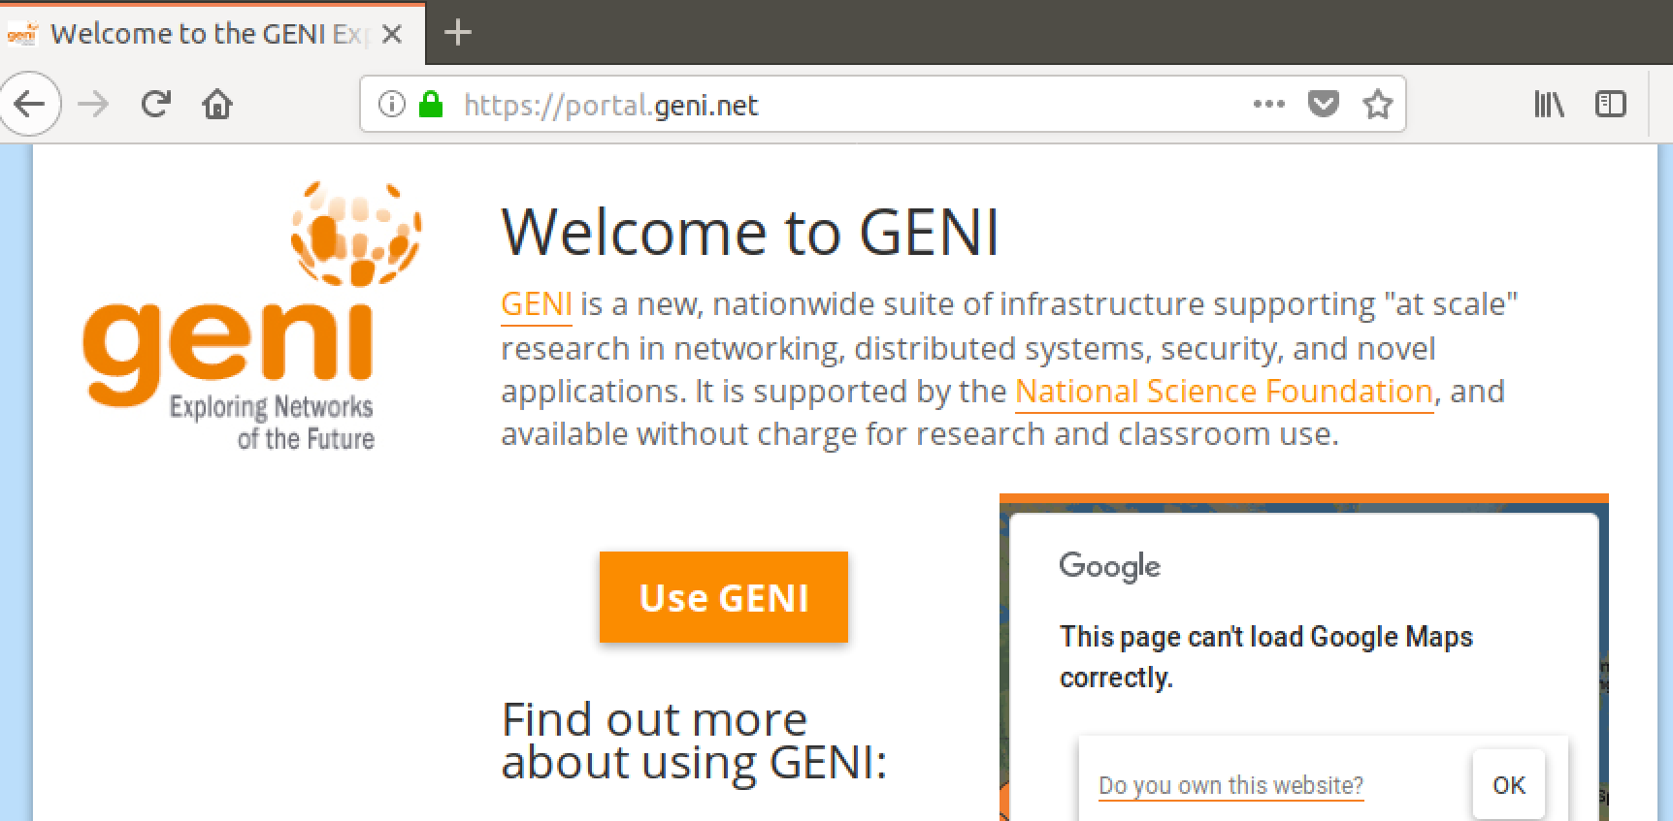

Clicking thebutton will take you to a directory of organizations that comprise the GENI Infrastructure.

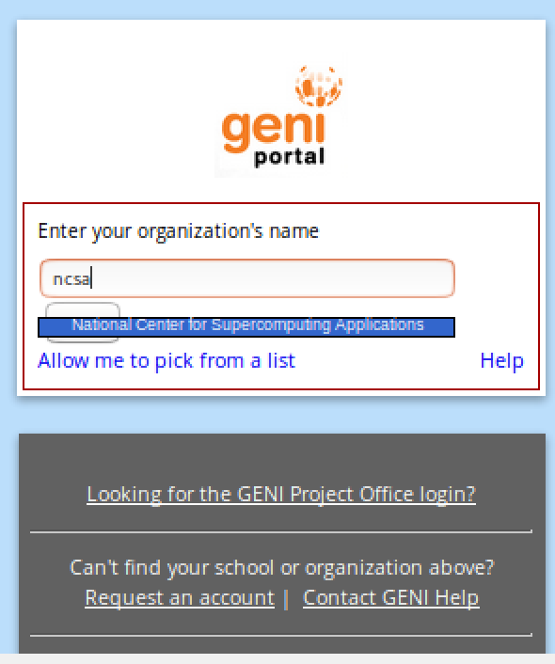

Type “ncsa” to search for the National Center for Supercomputer Applications. Click the link to take you to their login portal.

**2. Sign Up at NCSA**

The link on GENI will take you to the login portal for NCSA. You will authenticate through NCSA when we want access to the GENI portal (Dashboard) in the future.

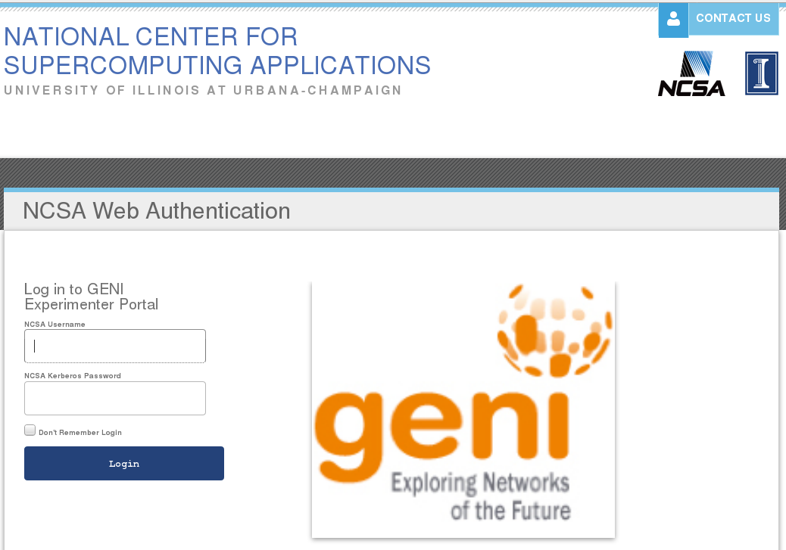

At the bottom you will see in smaller print links to manage user accounts.

Click the link Sign Up For An Account

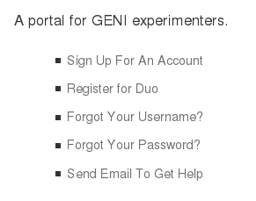

You will be presented with a standard sign up form associated with account creation. Fill in all required fields on this form.

* Request a unique username that is memorable but no larger than 8 characters.
* Use your student email (.edu)
* Specify Park University as the organization.
* Agree to NCSA’s Terms of Service
* Pass the Captcha (I am not a robot).
* Click Create and Join button

Upon successful submission, you will be taken to this web page.

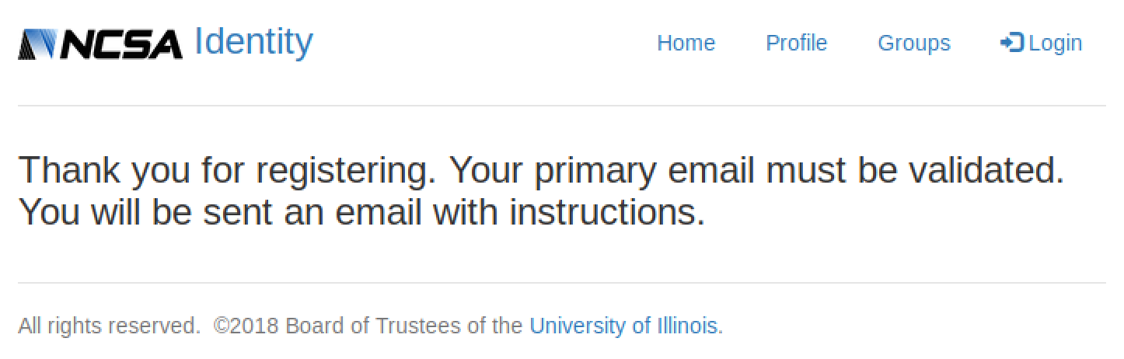

You should receive an email (hopefully instantly) asking for confirmation to finish the registration process. In the email is a code and a link. Make note of the code, and click the link to proceed.

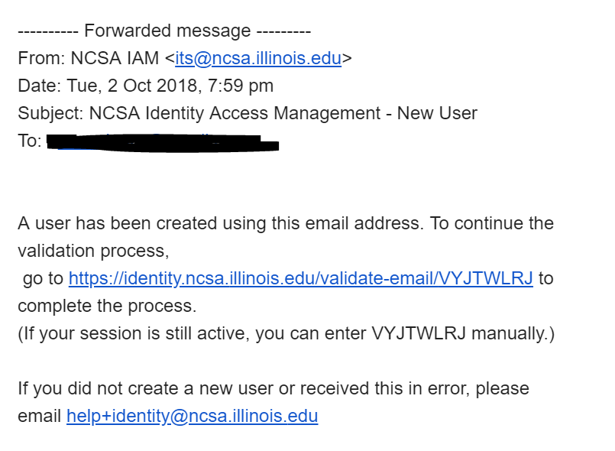

The link will take you back to NCSA to validate your email account. Enter your email and the code mentioned above.

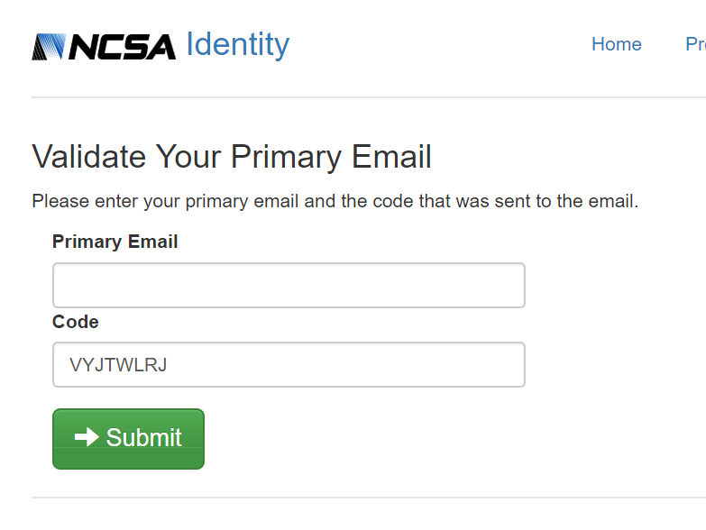

Validating your Primary Email will take you to another webpage to change your password. Click reset page, enter your unique username and desired password. Click Reset.

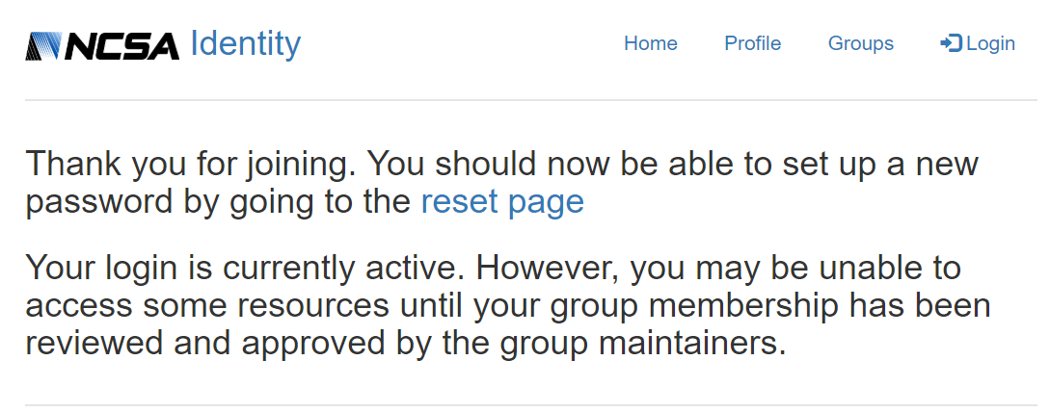

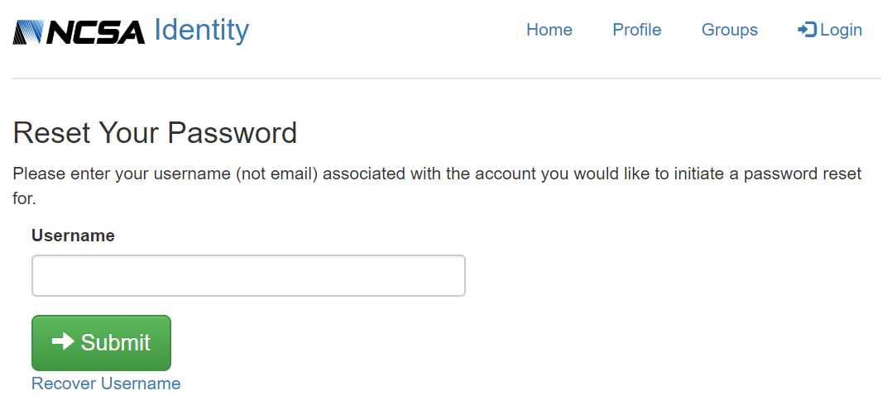

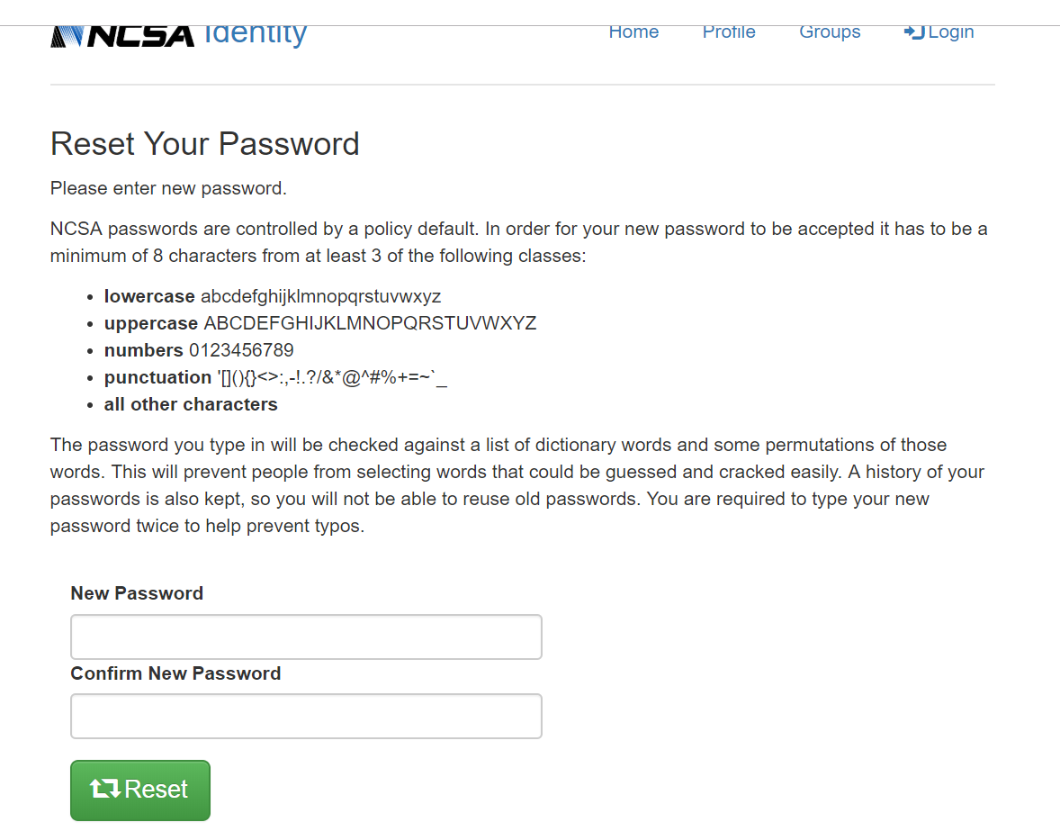

**3. Sign In to GENI Portal**

We need to get back to the GENI Portal to login. Visit <https://portal.geni.net> again and click



Now you should be taken to the same directory, except the NCSA logo should be displayed.

Click that logo.

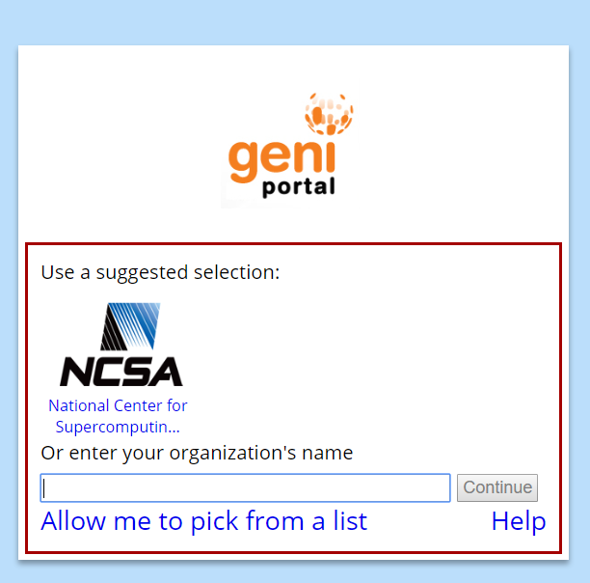

You should be taken back to the NCSA login page. Your login credentials may already be in place, if not fill in the relevant fields a click Login.

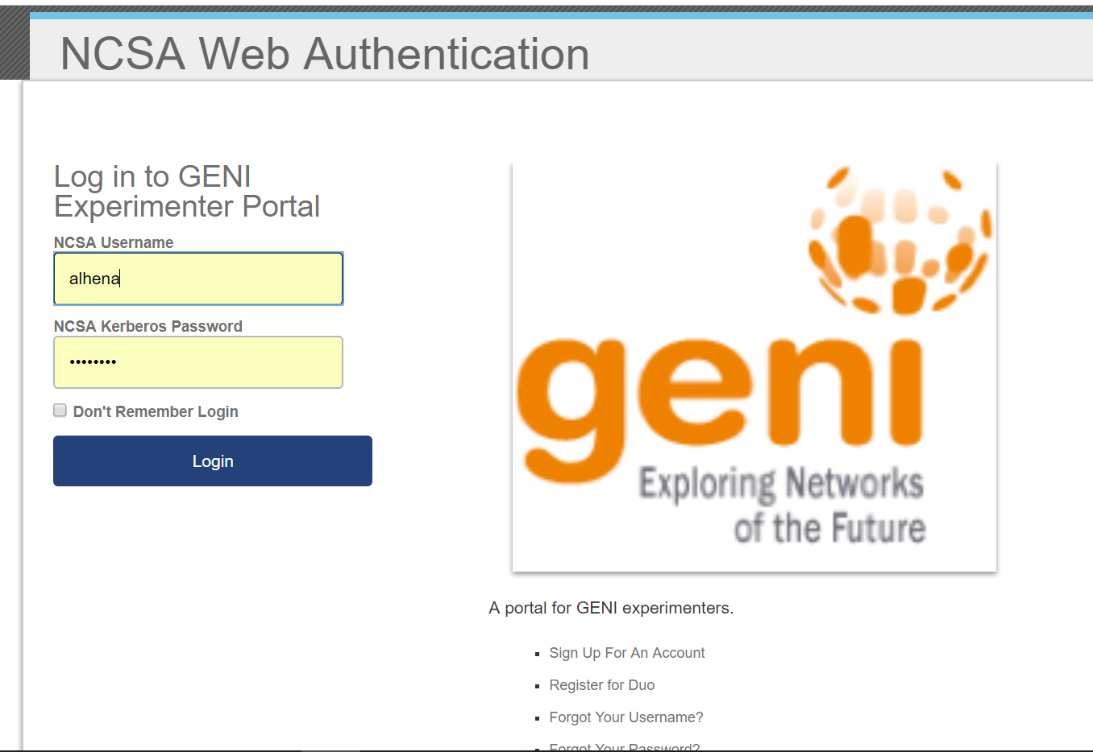

The next page will only appear on your first GENI login.

Check mark ‘Agree’ and ‘Authorize’ and click the Activate button.

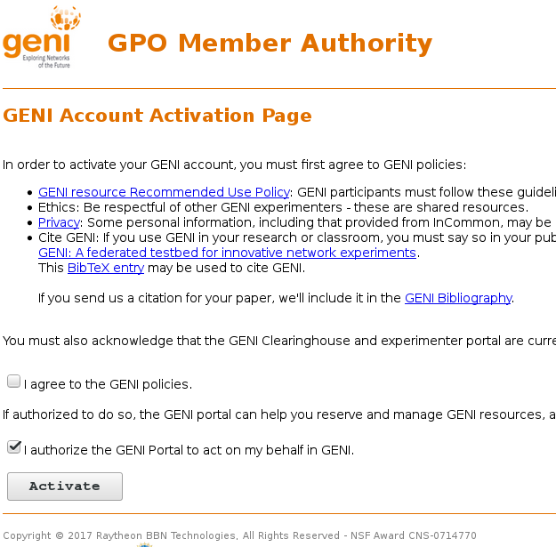

**4. Generate SSH Keys**

Finally, we have arrived at the GENI Portal for your user. Note the tabs on the top. The furthest right should be your username. Under this dropdown we find the button for ssh-keys.

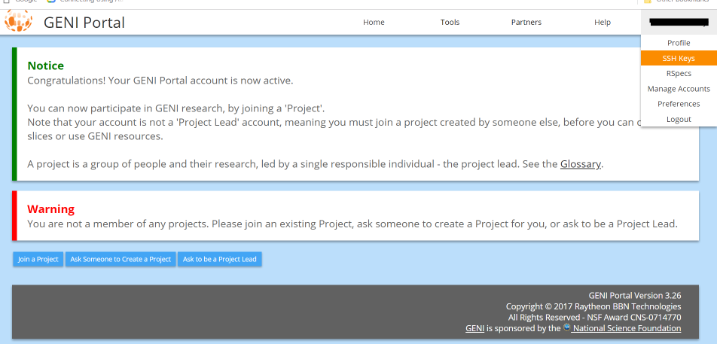

We need to generate ssh-keys to log in GINI VMs. Click SSH Keys button under your username.

On the next page, click the  button.

Provide a passphrase for your ssh-key. This will be your password to authenticate your SSH connection to the machines on GENI. Remember this or write it down.

**IMPORTANT: Never forget the passphrase. Otherwise, you will lose access to your virtual machines.**

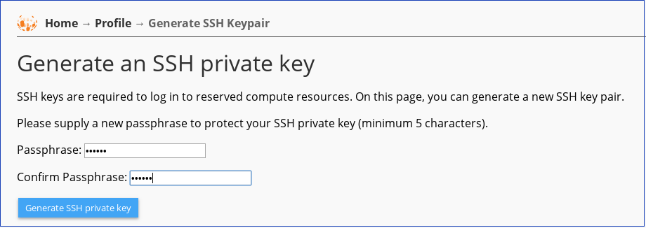

The following screen will display your ssh key and provide links for download. This page can be accessed in the future, if you ever need to find your key again.

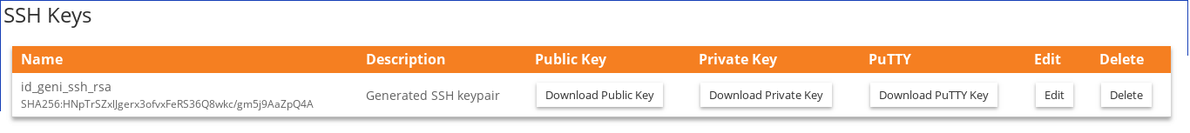

**If you are using Windows System**, now we need to download the Putty Key to the windows machine. Click the Download Putty Key button.

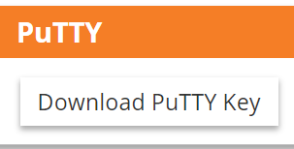

You will be asked to type in the passphrase you set when generating the SSH key. Fill in the passphrase and click “Download Putty key” button to download the putty key. The key file is named as “id_geni_ssh_rsa.ppk”.

**IMPORTANT:** Save the key file to a safe place. Do not share this key file with others. You will need it later to connect to the virtual machines.

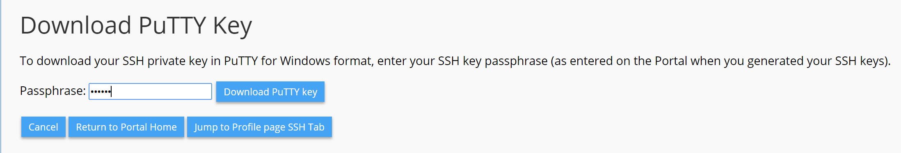

|  |
| --- |
| **Alternatively**, **if you are using Linux or Mac**, you can download the SSH Private Key instead. Follow the steps as follows:  Now we need to add this ssh-key for GENI into your Linux/Mac machine. Click the Download Private Key button.    On Linux/Mac machine, files are downloaded to **~/Downloads/** by default. We need to move our new private key into the folder **~/.ssh/**  If the folder .ssh/ does not exist, create it: **mkdir ~/.ssh/**  Move the key to the .ssh/ folder: **mv ~/Downloads/id_geni_ssh_rsa ~/.ssh/**  Restrict permissions on the key: **sudo chmod 0600 ~/.ssh/id_geni_ssh_rsa**  ***Information:*** Your SSH command will be something like:  **ssh -i ~/.ssh/id_geni_ssh_rsa [username]@[hostname] -p [port]**  The hostname will be provided to you when you make a “Slice” of the Project. This can be an IP address, a domain, or a string of characters that represents the logical address of the machine on the GENI infrastructure. *You don’t need to execute the above command at this time, but you will need this in the actual labs.* |

**5. Join a Project**

Now we have a valid GENI account, we will need to join the Project.

Click the  button in the bottom left side of the portal. This brings us a directory of active projects.

**Enter the project name provided by the instructor in the input form like below.** For example, suppose the project name is “ExampleProject”, simply type it in and click Join

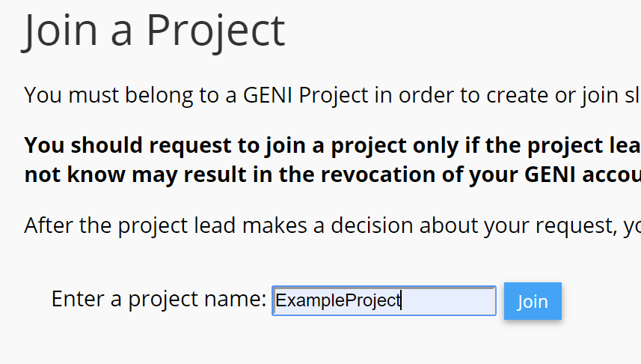

The following page allows a message to be sent to the Project Leader requesting permission to join. Fill out relevant information, and click Send Join Request.

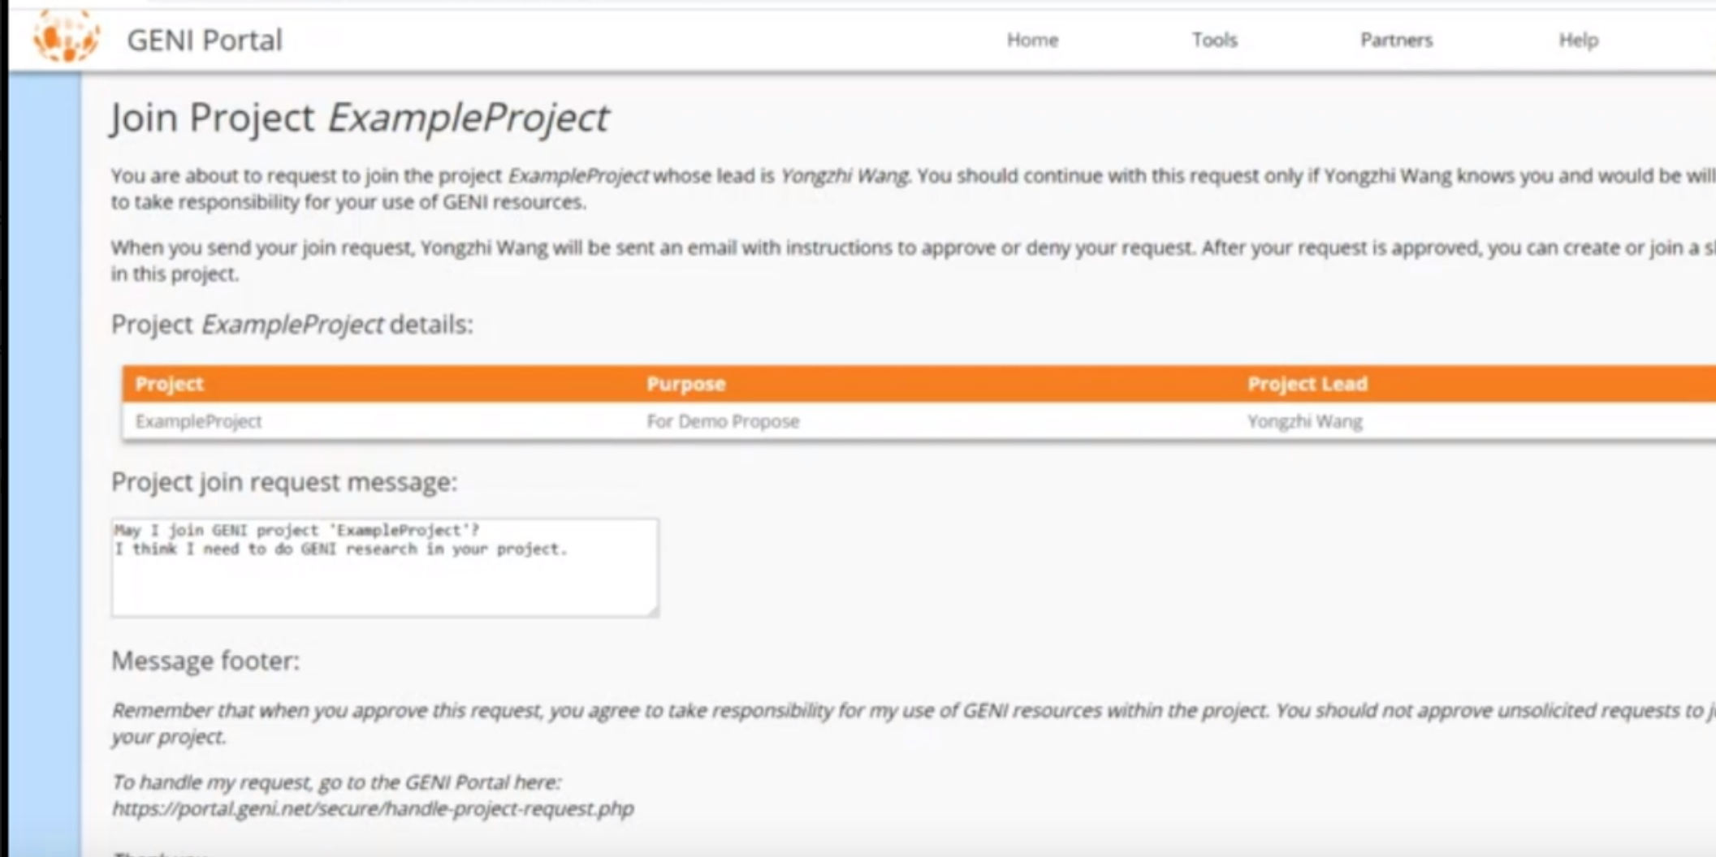

When your request has been accepted, you will see your available projects on the homepage of the portal.

Now, follow the instruction document of the specific lab.